

**Recep Tayyip Erdogan University**

**Faculty of Engineering and Architecture**

**Computer Engineering**

CE103- Algorithms and Programming - I

**Homework-3 (Week-6)**

**Fall Semester, 2021-2022**

|  |  |
| --- | --- |
| Instructor | Asst. Prof. Dr. Uğur CORUH |
| Contact Information | [ugur.coruh@erdogan.edu.tr](mailto:ugur.coruh@erdogan.edu.tr) |
| Google Classroom Code | **3ipdtws** |
| Publish Date | **14.11.2021** |
| Due Date | **25.11.2021 12:15** |

**Complete the following homework requirements, prepare them in the format given in the description below until the deadline and time, and upload them to the classroom's related assignment.**

**Grades:**

|  |  |
| --- | --- |
| Problem-1 | 100 points |
| **Total** | **100** points |

***Development Environment***

In this problem, you will add multi-language feature to existing console application. Multi-language example and existing console application working source codes are shared with you.

Download template from

<https://github.com/ucoruh/CE103-HW3-Template>

* You will use visual studio community edition 2022.
* You will use C for application development
* You will create Doxygen documentation for your application, there is undocumented code you will understand and explain existing source codes with doxygen comments.

***Grading Criteria***

1. *Github Code Sharing*
2. *Classroom Code and Report Sharing*
3. *Comments and Explanations*
4. *Code Indentation*
5. *Project and File Types*
6. *Code or Project Bugs (Not Running or Complaining)*
7. *Tests and Results*
8. *Algorithm Solution Methods and Explanations*

***Homework Outputs***

1. *Source Code (.rar with git tracked)*
2. *Source Code (github pushed link)*
3. *Homework Word Template*
4. *Doxygen Output (.rar)*

**Problem-1 (100 points):**

In this problem you will upgrade an existing app and you will add multi language support for a console application. This application will provide Turkish and English languages. Sentences on the screen will be stored on files. For example English words or sentences will be stored on **en.dat** and Turkish sentences and words will be stored in **tr.dat**. There will be configuration file **lang.dat** to keep language selection for user. If language is English then **en.dat** file content will be used otherwise tr.dat file will be used.

You will use the following working example “**DepartmentStoreManagementSystem**” and one more menu option for language selection such as “*Change Language*” to following list.

In the first time and run default will be Turkish language and if there is no selection for first time you will create default **lang.dat** for Turkish, then user can edit language from “Change Language” menu by selection with arrow keys (up or down) as below.

There is language example that you can use similar features for this homework “**LocalizationExample**”.

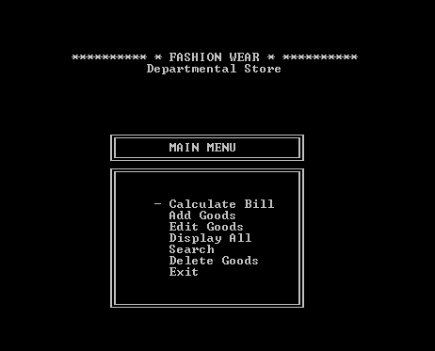

Develop or use required functions and do not share any code that you didn't understand. Explain your source code with inline comments.

Good Luck!